6,2 or 15.5/25

Question 1 - Item Response Functions and Person Estimates

1. Which item was the easiest item and which item was the hardest? (2 points)

The easiest question was number 5 and the hardest question was number 10.

## Provide a 95% conﬁdence interval for the easiest item and interpret it. (2 points)

The formula is: est plus or minus 1, 96 x SE(est)

- 1, 62671110 + 1, 96 x 0, 1320051 = 0,04399583

- 1, 62671110 – 1,96 x 0,1320051= -0,47346416.

We can be 95 % sure that the true easiest item difficulty lies somewere in the range between 0, 044 and – 0, 4785.

The numbers above are wrong, please see the answer key -1.5

(c) Provide a plot that contains both the easiest and the hardest item. (1 point)

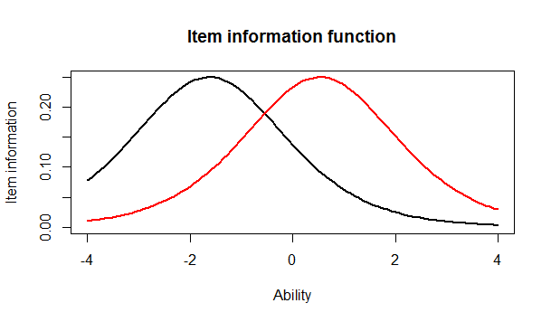

1. What would we expect the probability of a correct response would be for someone who had an ability score of 0 for these two items? (2 points)

That person knows medium. She doesn’t know it all but are not the worst either. -2. You can estimate this from the IRFs.

1. What was the score of the person who did the best on the test? What was the score of the person who did the worst on the test? (2 points)

The minimum score is 393 and the maximum score is 49. That is there ID not their score. What was there score? -1

(f) Provide a 95% conﬁdence interval for the estimated ability for the student who did the best on the test and interpret it. (2 points)

3.999921 + 1.96 * 2.204373 = 8.320492

3.999921 - 1.96 * 2.204373= -0, 3206501

We can be 95 % sure that the true ability for the student who did best on the test lies somewhere in the range -0, 320650 and 8, 320492. -.5

Question 2 - Information

For this question, you will choose three items to investigate.

1. Please state the three items you selected. (1 point)

1, 4 and 9

1. Provide a plot that contains these three items’ information functions. (1 point)

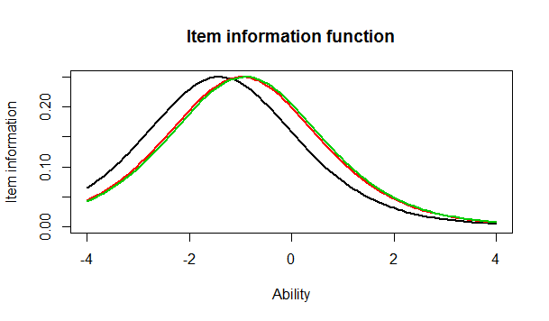

1. What is the same about these items’ information functions? What is diﬀerent? Hint: This can be a very short answer. (2 point)

The green and red questions have almost the same difficulty and location. The black question have higher location difficulty than the other two. The black question is also steaper than the other two. This last statement is not true. They are all the same steepness just different locations -.5

(d) Provide a plot of the test information function. (1 point)

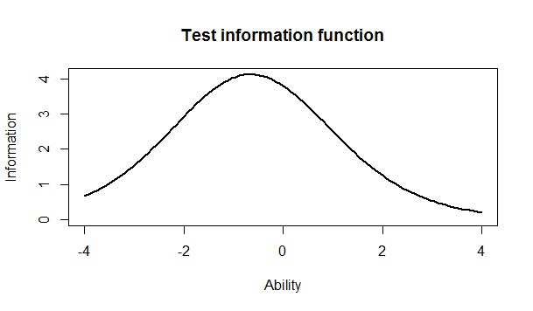

1. Where is the majority of the information for this test located? (1 point)

Ca -1.

Question 3 - Comparing the 2-PL

1. Which item had the highest discrimation? Which one had the lowest discrimination? (2 point)

Item 12 have the lowest discrimination (0, 3329130) and item 8 have the highest discrimination (2, 2881772).

1. Are the items that were the easiest and hardest in the Rasch model, also the easiest and hardest in the 2-PL? (1 point)

Yes. No, the hardest is the same but not the easiest. -1

1. What is the correlation between the ability estimates on the Rasch model and the 2-PL? If your interest was solely on estimating person abilities, do you think you would draw the same conclusions from both models? Why? (2 point)

No. The Rasch model: answer from person is determined forexample by his skills and his weight item and the probability of correct response is a function of the skills test taking and test weight of the item.

2 PL: Answer from person is determined by his skills, the weight of an item AND the items discrimination.

What is the correlation? The inferences drawn about scores is basically the same because the correlations are so high. -2

(d) Provide a plot of the item information function for the three items you selected in Question 2 but this time for the 2-PL model. (1 point)

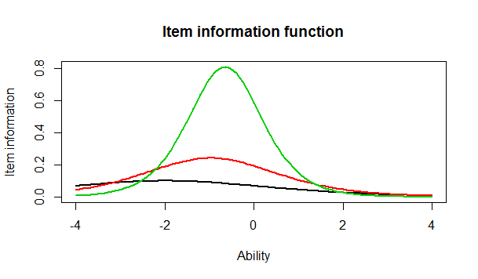

1. For the 2-PL model, how do the item information functions for these items diﬀer? How do the 2-PL item information functions from these items diﬀer from their Rasch item information functions? (2 point).

The green question have high correlation which tells us that we can not draw the same conclusion about the 2 other questions.

Please see the answer key. For the 2PL, they differ by shape and location within that model and compared to the Rasch model -2